**Project Design Phase-II**

**Data Flow Diagram & User Stories**

|  |  |
| --- | --- |
| Date | 03 October 2022 |
| Team ID | PNT2022TMID12586 |
| Project Name | Project - Nutrition Assistant Application |
| Maximum Marks | 4 Marks |

**Data Flow Diagrams :** **Nutrition Assistant Application**

A Data Flow Diagram (DFD) is a traditional visual representation of the information flows within a system. A neat and clear DFD can depict the right amount of the system requirement graphically. It shows how data enters and leaves the system, what changes the information, and where data is stored.

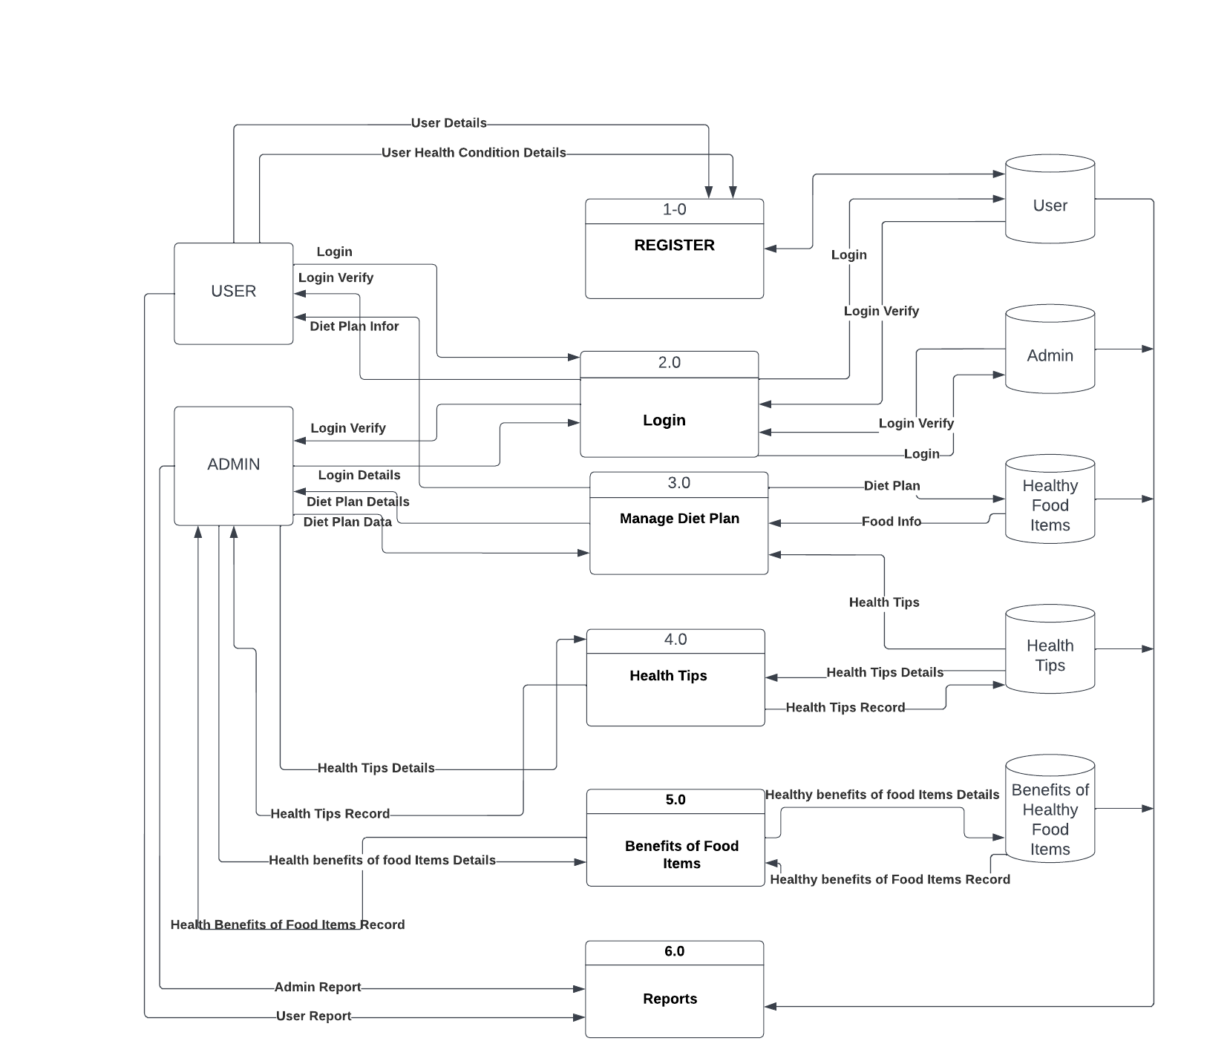

**User Stories: NUTRITION ASSISTANT APPLICATION**

Use the below template to list all the user stories for the product.

| **User Type** | **Functional Requirement (Epic)** | **User Story Number** | **User Story / Task** | **Acceptance criteria** | **Priority** | **Release** |
| --- | --- | --- | --- | --- | --- | --- |
| Customer (Mobile user) | Registration | USN-1 | As a user, I can register for the application by entering my email, password, and confirming my password. | I can access my account / dashboard | High | Sprint-1 |
|  |  | USN-2 | As a user, I will receive confirmation email once I have registered for the application | I can receive confirmation email & click confirm | High | Sprint-1 |
|  | Login | USN-3 | As a user, I can log into the application by entering email & password | I can enter into the nutrition application development application | High | Sprint-1 |
|  | Dashboard | USN-4 | As a user, I can able see the dash board in the Nutrition Application Development. | I can view the details | Medium | Sprint-1 |
|  | Food Log | USN-5 | As a user, I can click the menu | I can receive the Food details | High | Sprint-1 |
|  | Calorie Calculator | USN-6 | As a user, I can enter the details of age, weight, gender details of the user | I can receive the Calorie information about the food to eat | High | Sprint-1 |
|  | Diet Plan | USN-7 | As, a user I can view the diet plan by clicking menu using the mouse | I can view the information | High | Sprint-1 |
|  | Alerts & Notifications | USN-8 | As a user, I can receive the alerts and notifications as soon as enter into the App | I can view the information | Medium | Sprint-1 |
| Administrator | Login | ADMN-1 | As a admin, I can login into the application by providing mail id and password | I can enter into the nutrition application development application | High | Sprint-1 |
|  | Manage Databases | ADMN-2 | As a admin, I can able to create databases | I can able access the tables | High | Sprint-1 |
|  |  | ADMN-3 | As a admin, I can able to update the database | I can able to modify the contents of the database | High | Sprint-1 |
|  |  | ADMN-4 | As a admin, I can able add the contents to the database | I can able to add the content to the tables | High | Sprint-1 |
|  |  | ADMN-5 | As a admin, I can able to remove the contents of the databases | I can able to delete the unnecessary information from the database | High | Sprint-1 |
|  | Manage Reports | ADMN-6 | As a admin, I can generate reports | I can able to see the reports in the correct format | High | Sprint-1 |